Name:

ID:

M5 Exam

<https://repl.it/@enaard/Python-3>

1) Consider the following:

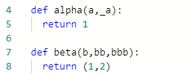

* Which function has more parameters?

2) What is the sum of the last element of range(2)?

|  |  |
| --- | --- |
| 102 | 101 |
| 100 | 98 |
| 2 | 0 |
| 200 | 1 |
| 49 | 50 |

3) Which of the following has a Boolean value?

|  |  |
| --- | --- |
| True | “””False””” |
| “”Boolean””” | 1 % 2 |
| “Bool” | 1 + 1 + 1 |

4) Which of the following correctly sums the “a1” and “a3” keys of myDic?

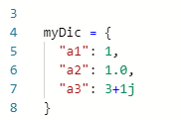

|  |  |
| --- | --- |
| “a1” + “a2” | myDic(a1) + myDic(a2) |
| myDic[“a1”] + myDic[“a2”] | myDic(“a1”) + myDic(“a2”) |
| myDic{a1} + myDic{a2} | myDic |
| myDic{“a1”} + myDic{“a2”} | a1 + a2 |

5) What is the output: 3*”a” + “b”*2?

|  |  |
| --- | --- |
| 3a+b2 | ab |
| aaab2 | 3ab2 |
| 32 | 6ab |
| aaabb | ab6 |